

Clarke Manufacturing Inc. 13388 S. Molalla Forest Rd. Molalla OR. 97038

Part # 11610 RMZ450 FUEL INJECTED 2008-2010
2.4 GALLON FUEL TANK

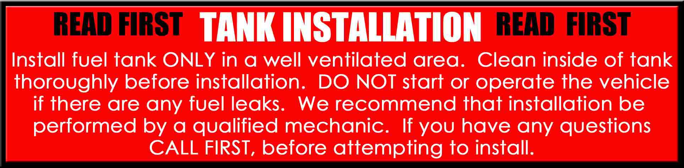

Thank you for purchasing a Clarke fuel tank. The following instructions will help you install this tank on a RMZ450 2008-2010 four stroke motorcycle. There may be some plastic shavings left in the tank from the manufacturing process. You can use compressed air to blow out the tank. You may also want to rinse out the tank using a small amount of fuel before installing it.

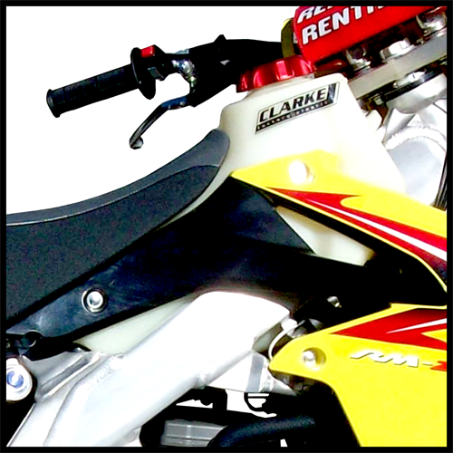

PLEASE SEE THE REVERSE SIDE OF THIS PAGE FOR INSTALLITON INSTRUCTIONS

IMPORTANT: THE MAXIMUM TORQUE SPECS FOR THE FUEL PUMP BOLTS IS 5 FT LBS.
DO NOT EXCEED 5 FT. LBS OF TORQUE WHEN RE-INSTALLING THE FUEL PUMP OR YOU WILL SPIN THE BRASS INSERTS AND VOID THE WARRANTY ON THIS TANK.

1.) Begin by removing your old tank, shrouds, seat and fuel injection unit. Drain your old tank in a well ventilated area. You may want to refer to your owners/service manual for proper removal and installation of the fuel pump unit.

2.) Remove the fuel pump assembly from your original tank. Mount the fuel pump unit to the new Clarke tank making sure the o-ring seal is not bound and fits tight. A little all purpose oil will aid installation. After you make sure everything is aligned and secure with no o-ring binding, tighten down all the bolts for the unit.

3.) Now put a small amount of fuel into the tank and tip it forward so the gas is located over the fuel pump area. Check for any leakage around the pump seal.

4.) Transfer the rear seat mount stud to the new tank. The tank is now ready for installation.

5.) Slip the tank carefully into the frame and then check to make sure you have no pinched fuel lines
or wiring interference.

6.) Align the front grommet mount hole over the frame and use your stock bolt and the supplied washer to bolt it down to the frame.

7.) Re-Attach the rubber tank strap to its original location at the rear

8.) Hook up fuel lines and make sure everything looks OK in the fuel pump assy. And fuel system hookup.

9.) Install the radiator shrouds.

10.) Now fill the tank with fuel and check for any leaks.

11.) Re-install the seat.

12.) Go back and make sure all bolts and screws are secure. You are now ready for riding.
Enjoy your new Clarke tank.

