
Clarke Manufacturing Inc. 13388 S. Molalla Forest Rd. Molalla OR. 97038

Part # 1480 KAWASAKI KLX250S DUAL SPORT
2.7 GALLON FUEL TANK

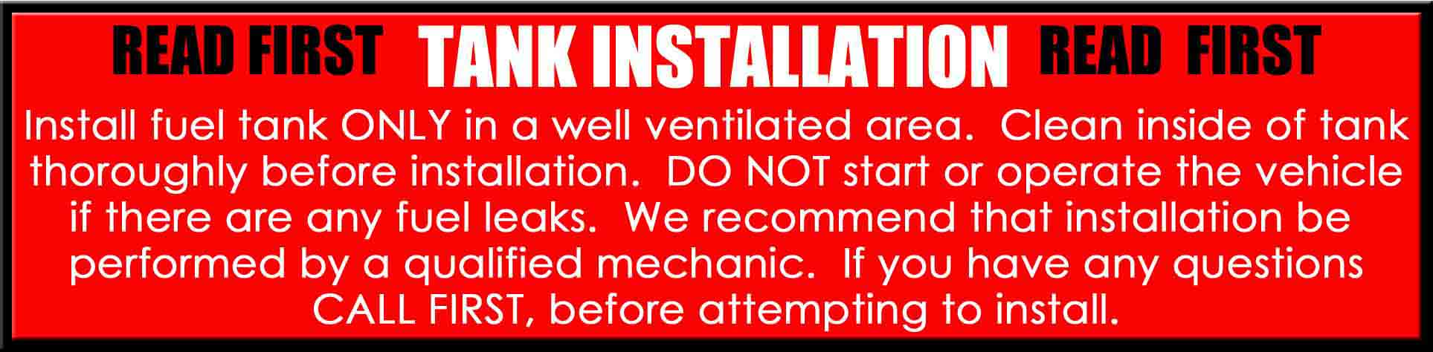

Thank you for purchasing a Clarke fuel tank designed to fit the KLX250S Dual Sport motorcycle. There may be some plastic shavings left in the tank from the manufacturing process. You can use compressed air to blow out the tank. You may also want to rinse out the tank using a small amount of fuel before installing it. The instructions on the back side of this page will help you to install your new tank properly. Upon purchase and installation the consumer assumes all liability and is solely responsible for compliance with all local and federal laws. PLEASE NOTE** Due to the configuration of the fuel lines and vent hoses, in addition to the overall lack of space to work with on this bike, a healthy dose of patience will
be required whether it is installing the Clarke tank or re-installing the original. If you are not comfortable working on this bike, please have a qualified mechanic install the tank.

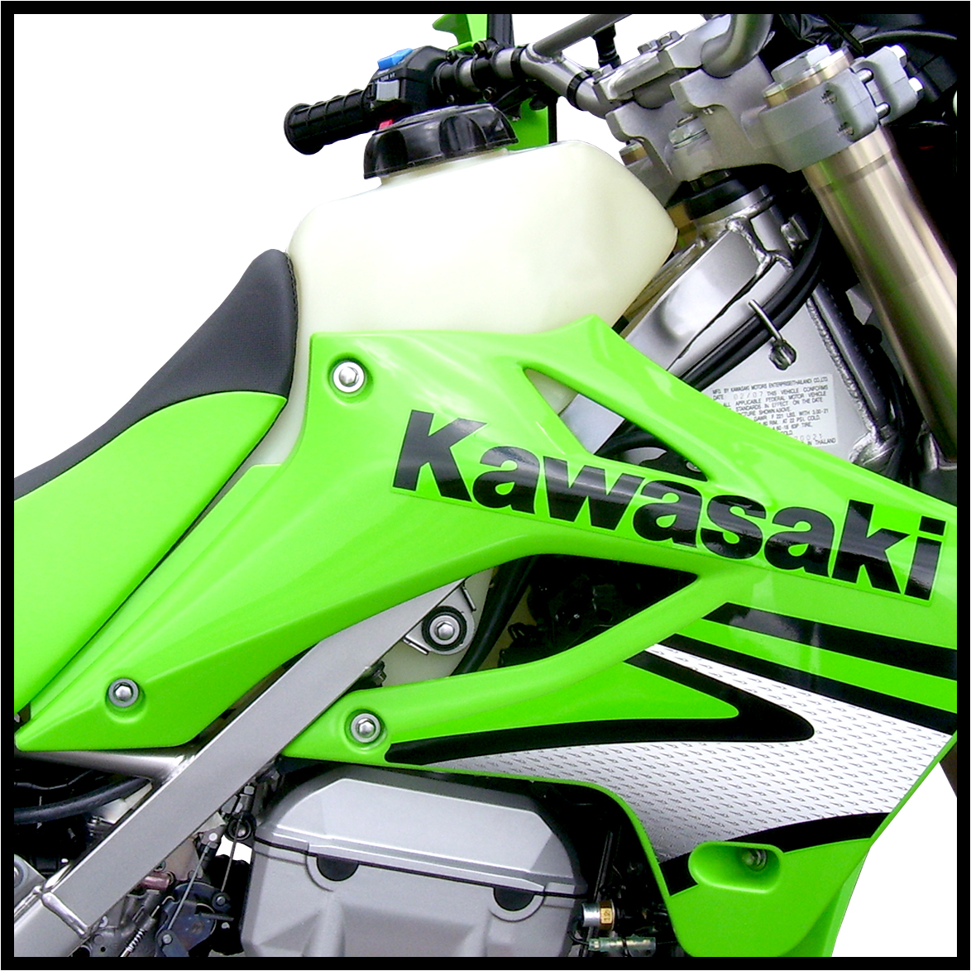

1.) Begin by removing the seat and shrouds from the bike.

2.) Remove the bolts from the main tank mounts on the sides and at the rear of the original tank.
This will help to make the tank loose in the frame and allow you to more easily manipulate the fuel lines during the next step.

3.) The 2 very long hoses that are attached to the original tank but not connected to the petcock will not be used on the new Clarke tank. They are in place on the original tank because it is metal and has a
locking cap. They are vapor vent lines and do not flow fuel. Lift the tank out of the frame a bit and disconnect these hoses ONLY ( Do NOT disconnect the actual fuel line yet. ) Now completely remove
these 2 lines by pulling them gently out of the frame from the bottom of the bike.

PLEASE SEE THE REVERSE SIDE OF THIS PAGE FOR INSTALLATION INSTRUCTIONS

4.) The fuel will now need to be drained from the original tank. You will need something to drain the fuel into. A bucket is probably best as it has a wide mouth and can catch the fuel easily. Since the KLX250S
does not have a traditional petcock where you can simply turn the fuel OFF and remove the tank and petcock as one unit, you will have to simultaneously pull the fuel hose off and quickly direct the flow
of fuel into the catch can/bucket. This can be tricky as there is almost no room to manipulate the hose into position because it is “hidden” behind the frame rail. You will want to drain the tank from the “reserve” fuel line to ensure that all of the fuel is drained from the tank. Try and get some slack on the fuel line and make a plan as to how you will direct the fuel line into the bucket. A good long pair of needle nose pliers will help you to slide the hose clamp out of the way and pull off the hose from the barb. Also you can use them to pinch the line shut for minimal spillage of fuel. Having the tank mount bolts removed will allow you to move the tank up and down in the frame and get a little room for you to work.

5.) Using the suggestions in the preceding step, drain the fuel from the original tank.

6.) You can now completely remove the original tank from the bike. There will no doubt be a small amount of fuel left in the tank so be careful when removing the tank to avoid additional fuel spillage.

7.) Turn your original tank over and remove the brass hose fittings from the fuel outlet area of the tank
and install them into the new Clarke tank taking care not to cross thread the insert and making sure the
o-ring seal is positive. Hand tighten, and then carefully snug them up using an end wrench. Do not over tighten the brass hose fittings. WE RECOMMEND A FUEL RESISTANS THREAD SEALER TO BE APPLIED. NO MORE THAN 5 LBS OF TORCH PRESURE

8.) Place the Clarke tank into the frame and wiggle it down into position between the side mount bushings. It will be a nice tight fit. Align the rear mount grommet over the mount hole but do not install the rear bolt yet.

9.) Now install the side mount bolts by starting one side in a few threads and then doing the same with the other side. Once you have both side mount bolts started, install the rear mount bolt and check fit. If you are happy with where everything is, go ahead and tighten all three mount bolts.

10.) Using the needle nose pliers, work carefully and install the fuel lines onto the new tank and petcock making sure they are pushed all the way on and that the hose clamps are back to their original positions.

11.) Now fill the tank and check for leaks. Clarke tanks are pressure tested with air before they are shipped but this is a necessary precaution.

12.) You can now re-install your radiator shrouds. Start all bolts loosely and then tighten them down.

13.) The new Clarke tank is equipped with a forward seat mount spacer, screw and washer. This will be where the seat mounts to the bike. As it is on the stock tank, the seat will be difficult to re-install.
Be patient and try to align the groove to the mount. This can be hard to see because the seat is in the way of what you are trying to view. Hold the front of the seat tight against the tank and hold the tail of the seat up in the air by bending the seat down and forward at the front. Slide the seat forward and onto the groove making sure to also get the plastic seat base “hook” to go under the area where it needs to be.
The tool bag will be in the way. The rear side panels will be in the way. Again, patience is key. Finesse the seat into position and then install the seat mount bolts at the rear and tighten them down.

14.) You are now ready for riding. Enjoy your new Clarke tank and the additional range you will gain from the extra capacity.

