

Clarke Manufacturing Inc. 13388 S. Molalla Forest Rd. Molalla OR. 97038

Part #11494 YAMAHA XT225
4.1 GALLON FUEL TANK

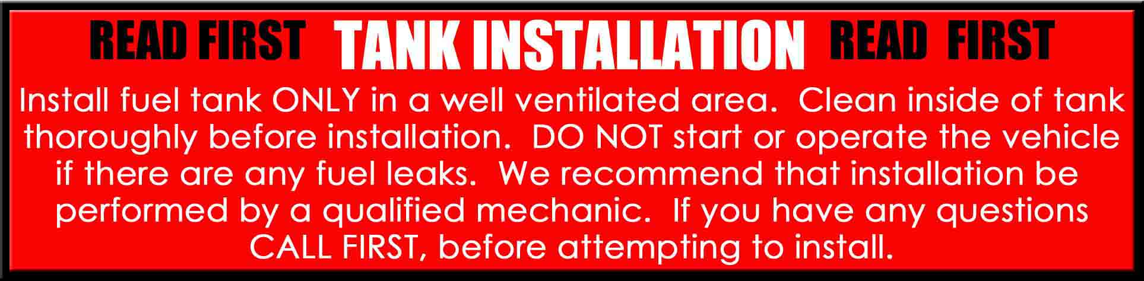

Thank you for purchasing a Clarke fuel tank. The following instructions will help you install this tank on all years of the XT225 motorcycle. There may be some plastic shavings left in the tank from the manufacturing process. You can use compressed air to blow out the tank. You may also want to rinse out the tank using a small amount of fuel before installing it. The instructions on the back side of this page will help you to install your new tank properly. Please note that this tank will not use the factory “Air Scoops”

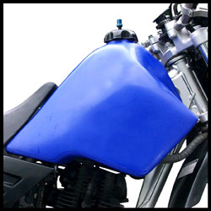

PLEASE SEE THE REVERSE SIDE OF THIS PAGE FOR INSTALLATION INSTRUCTIONS

1.) Begin by removing your old tank and petcock. Drain your old tank in a well ventilated area.

2.) Install the petcock from your old tank onto the new one by inserting it into the tank using the supplied flat gasket and your original petcock o-ring. Make sure to screw it down very tight.

3.) Take the padding provided and zip-tie it to the frame as shown in the picture. The padding is supplied to provide more stability to the tank since there are no support pads as is typical on most plastic tank applications.

4) You must relocate the horn to accommodate the front of the tank. A bracket is supplied to do this.
You will need to remove your horn bracket and then use the grommet and insert from your old bracket as shown in the photo to mount the horn in its new proper position.

5.) The right and left side panels will need to use the supplied brackets for proper fit and location as well.
It is best to use the supplied bracket and install it almost tight, then “plug” in the side panel and check for fit. When you are happy with the fit, take off the side panel and tighten the bracket to its proper and final position.

7.) Now place the tank over the frame and push it forward into position on the rubber pucks (front mounts)
Align the rear bracket over the factory rear mount and use the stock hardware and grommet/spacer etc to bolt the tank down tightly.

8.) Turn the petcock to “OFF”. Fill the tank with fuel and check for leaks.

10.) Re-install the seat and fasten the seat mount bolts securely make sure all bolts are tight and the
petcock is secure.

11.) You can now go back and re-install the side panels to the new brackets/grommets on either side.

12.) Go back over your work and make sure all bolts are secure and the fuel line is properly attached. You should
now ready for riding. Enjoy your new Clarke tank.

PLEASE REFER TO THE NEXT PAGE FOR DETAILED PICTURES
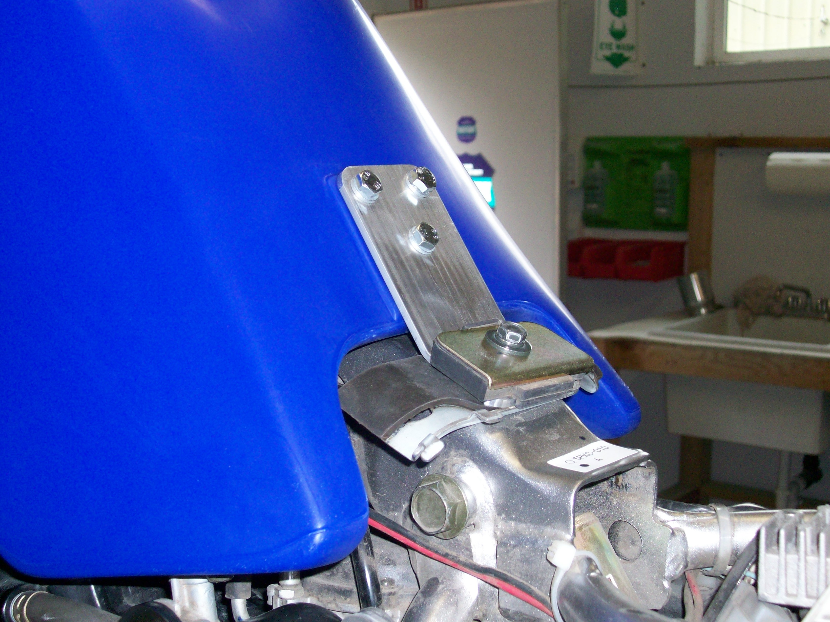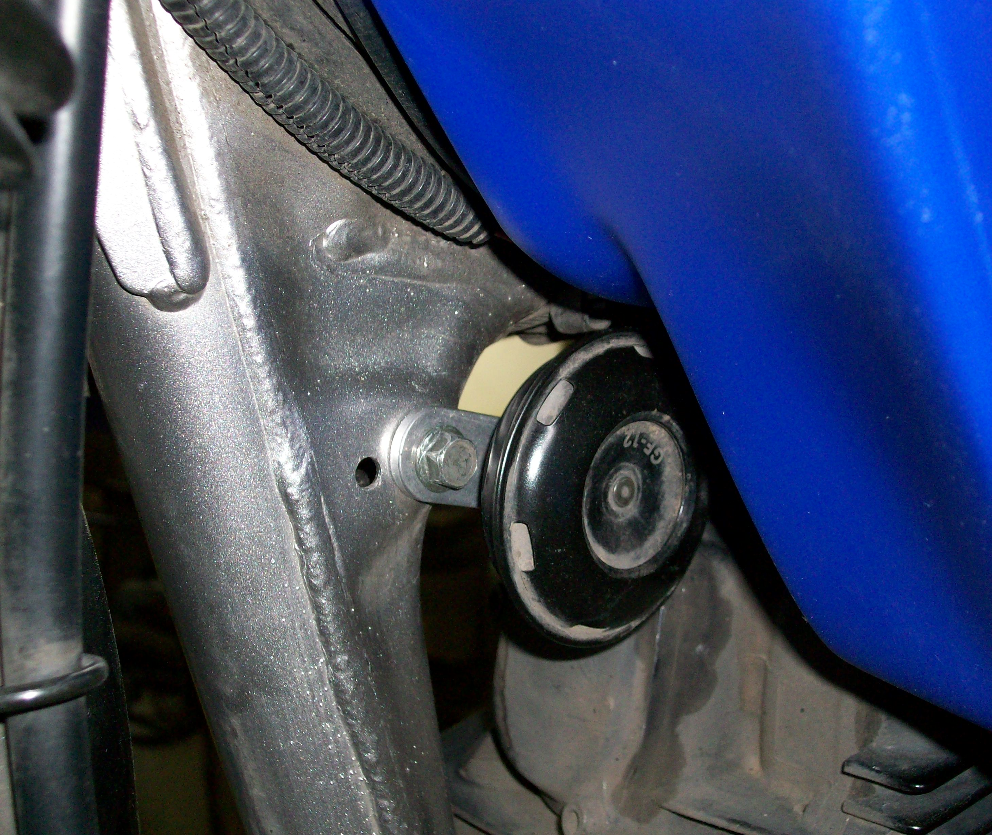
REAR MOUNT BRACKET HORN RELOCATED WITH SUPPLIED
WITH STOCK HARDWARE BRACKET

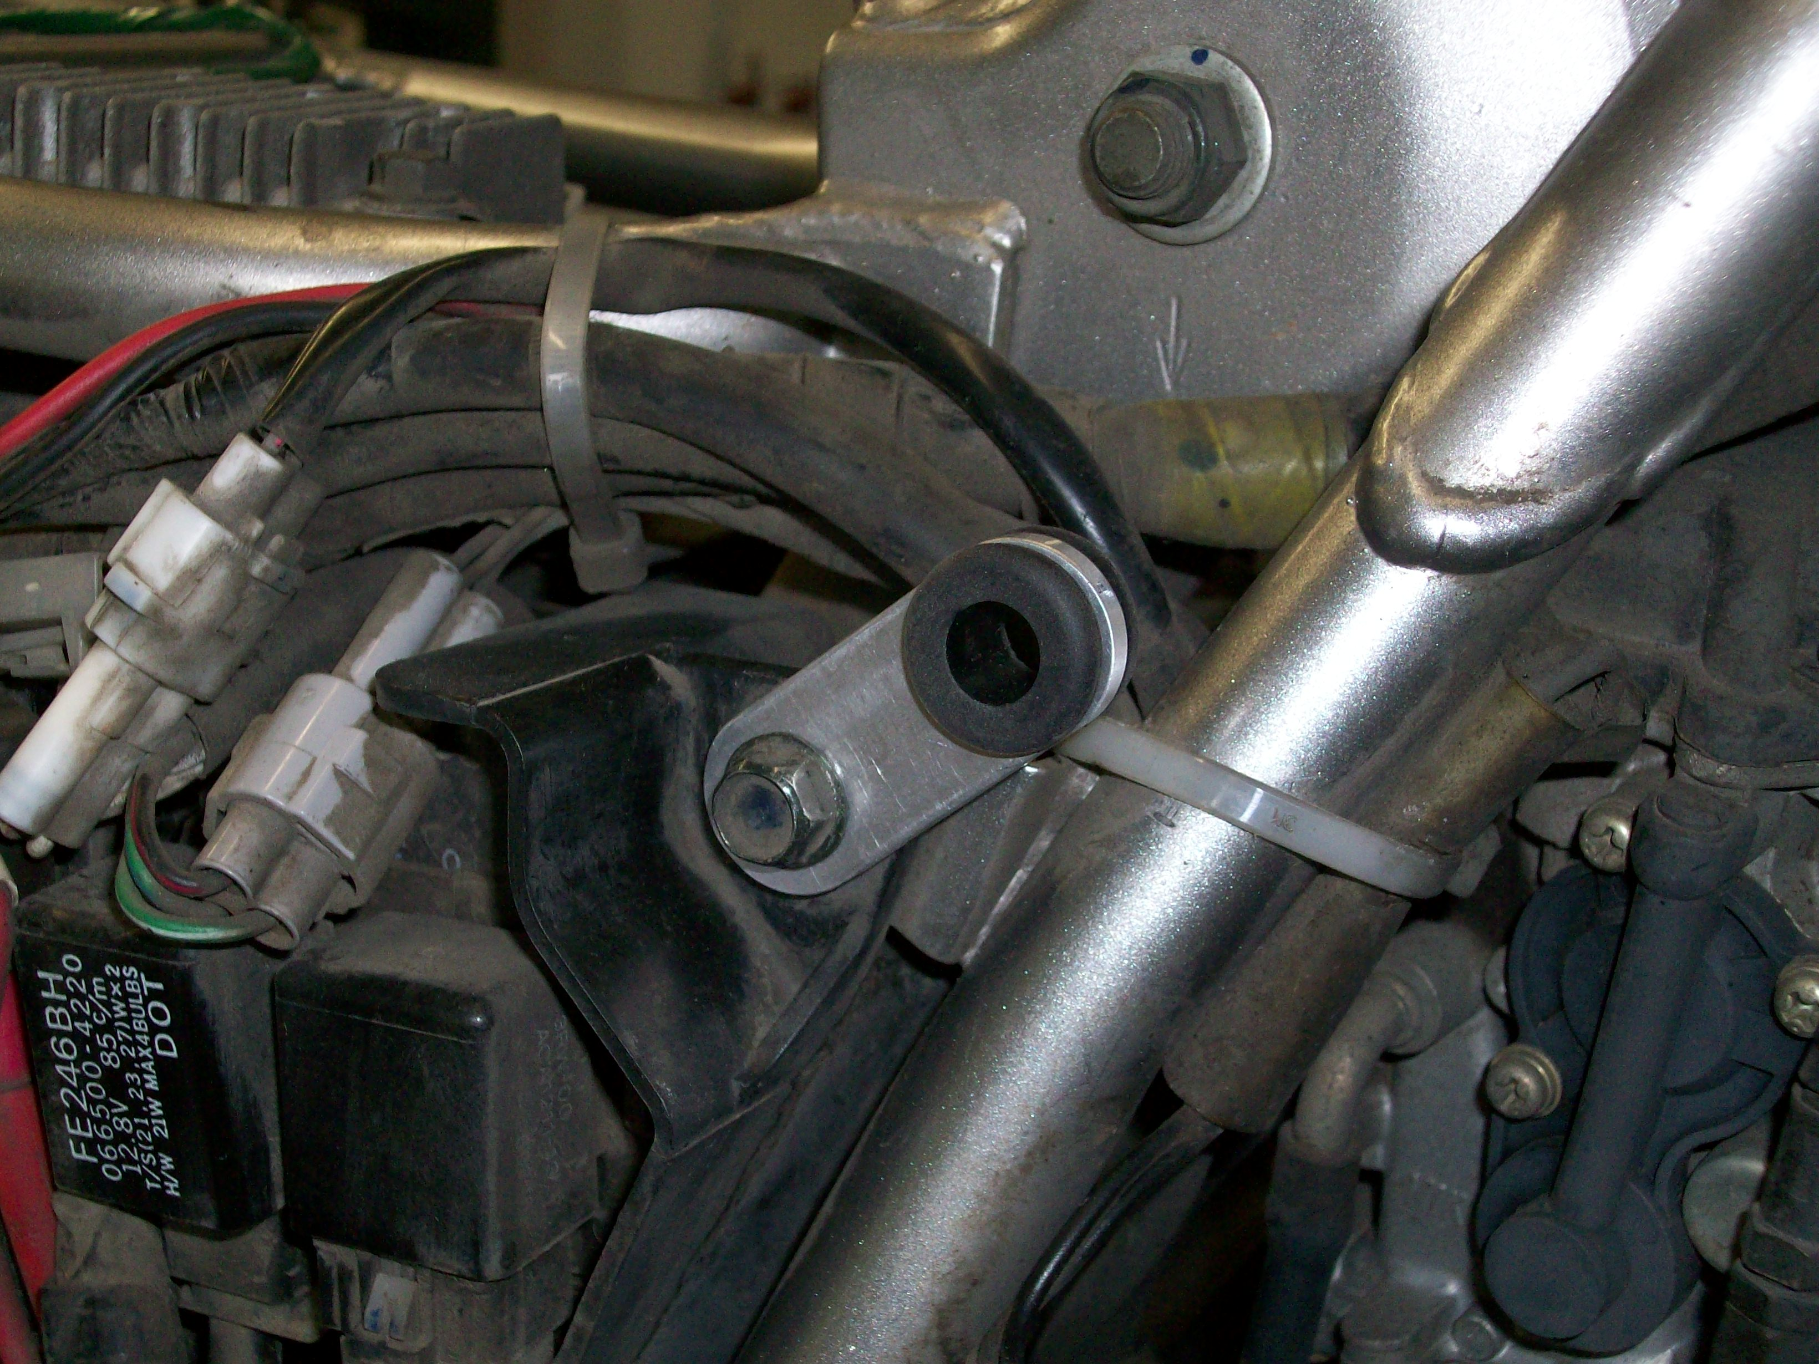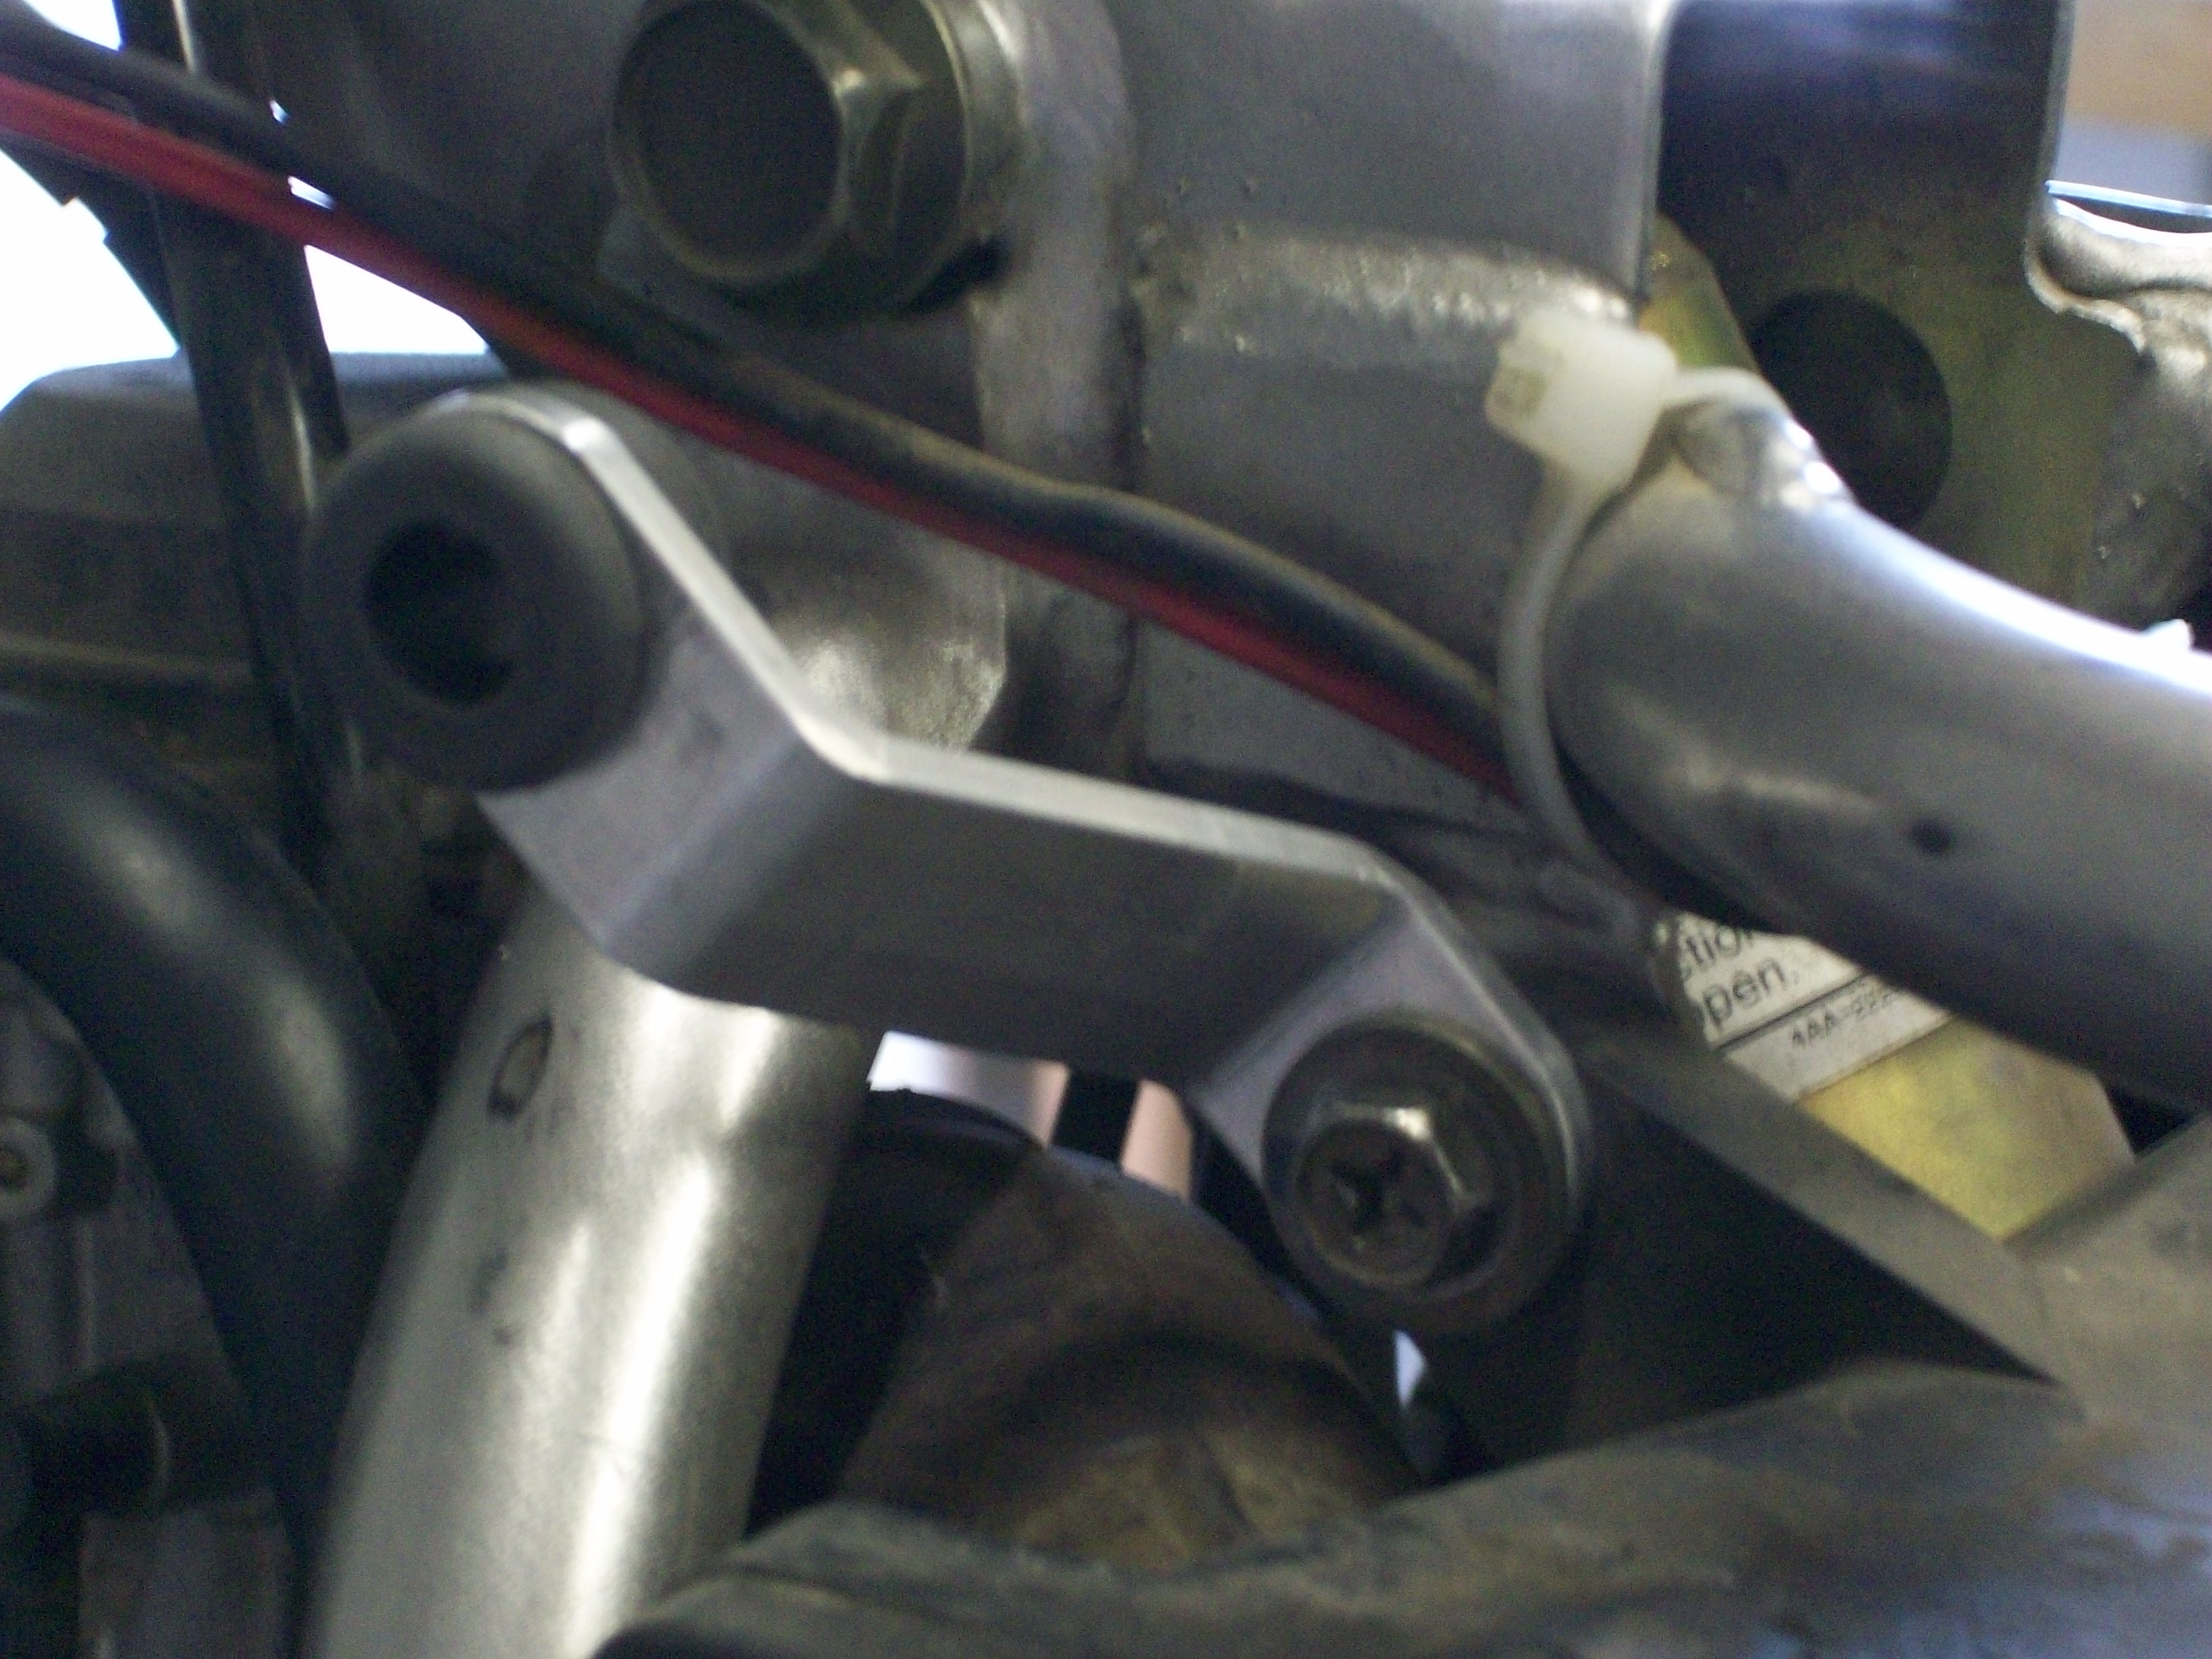
SIDE PANEL BRACKET/GROMMET SIDE PANEL BRACKET/GROMMET
RIGHT SIDE LEFT SIDE

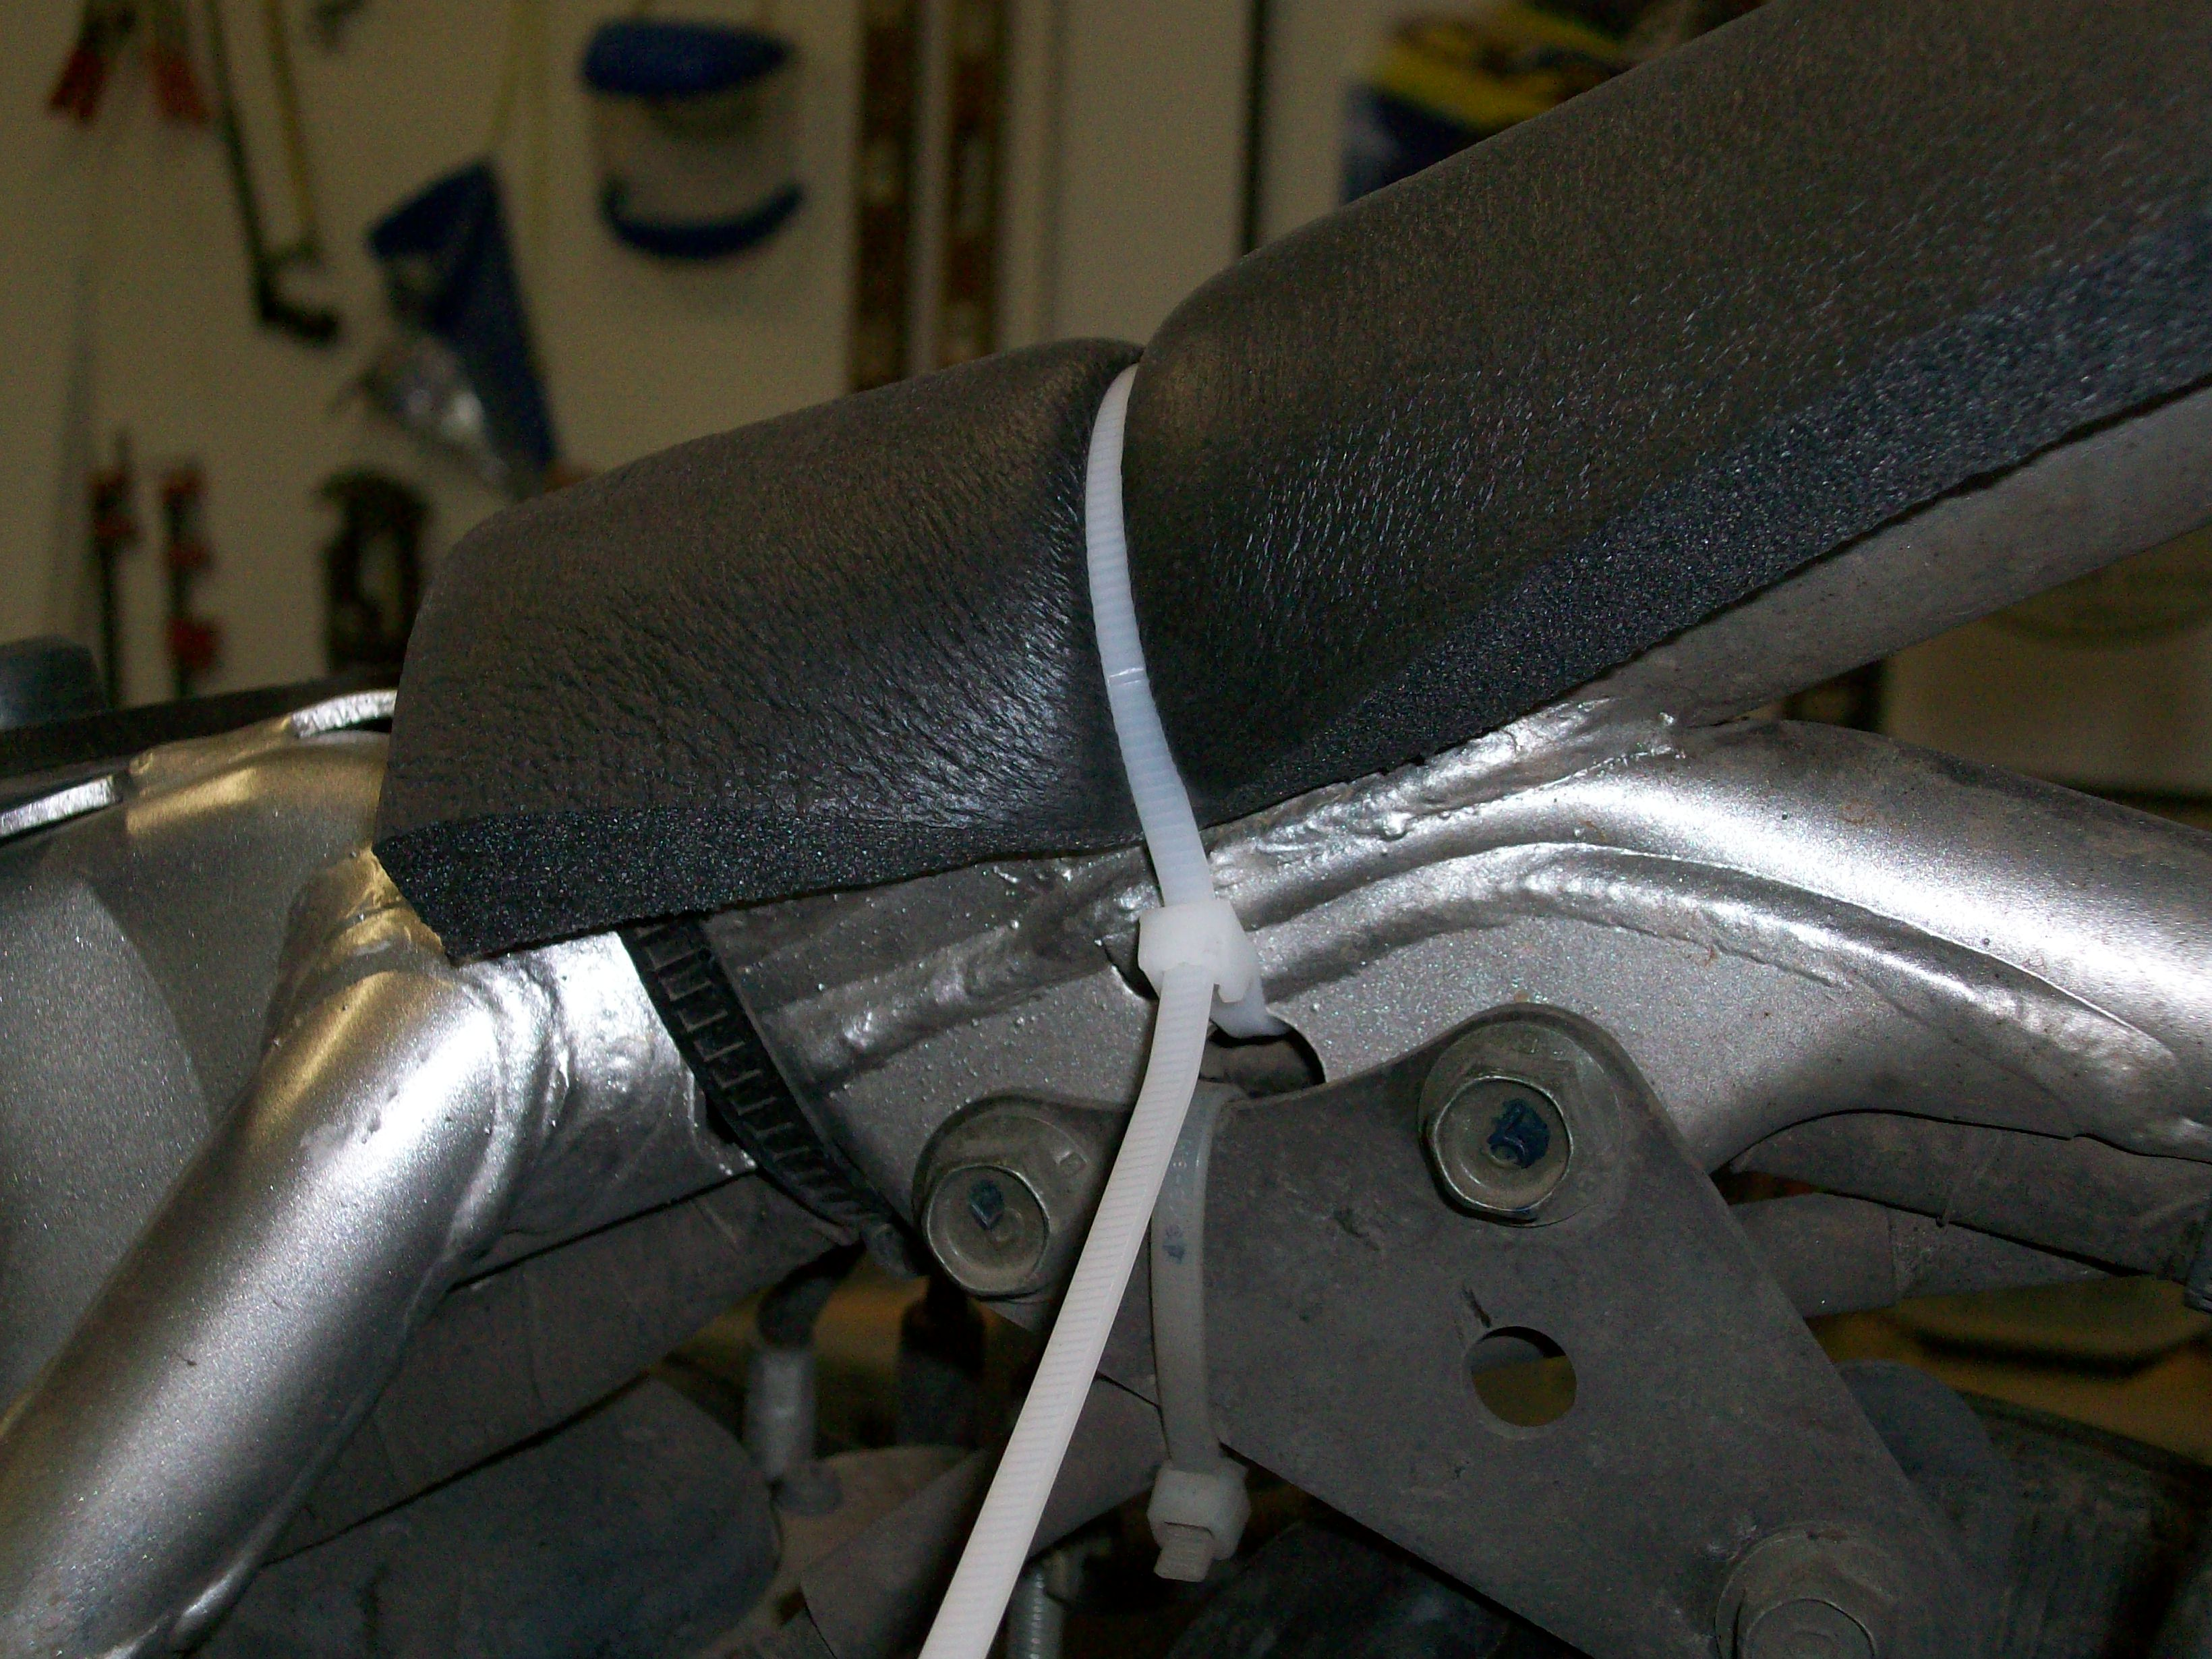
TANK PADDING INSTALLED TO FRAME

