

Clarke Manufacturing Inc. 13388 S. Molalla Forest Rd. Molalla OR. 97038

Part # 11614 YAMAHA YZ450F FUEL INJECTED
2.8 GALLON FUEL TANK

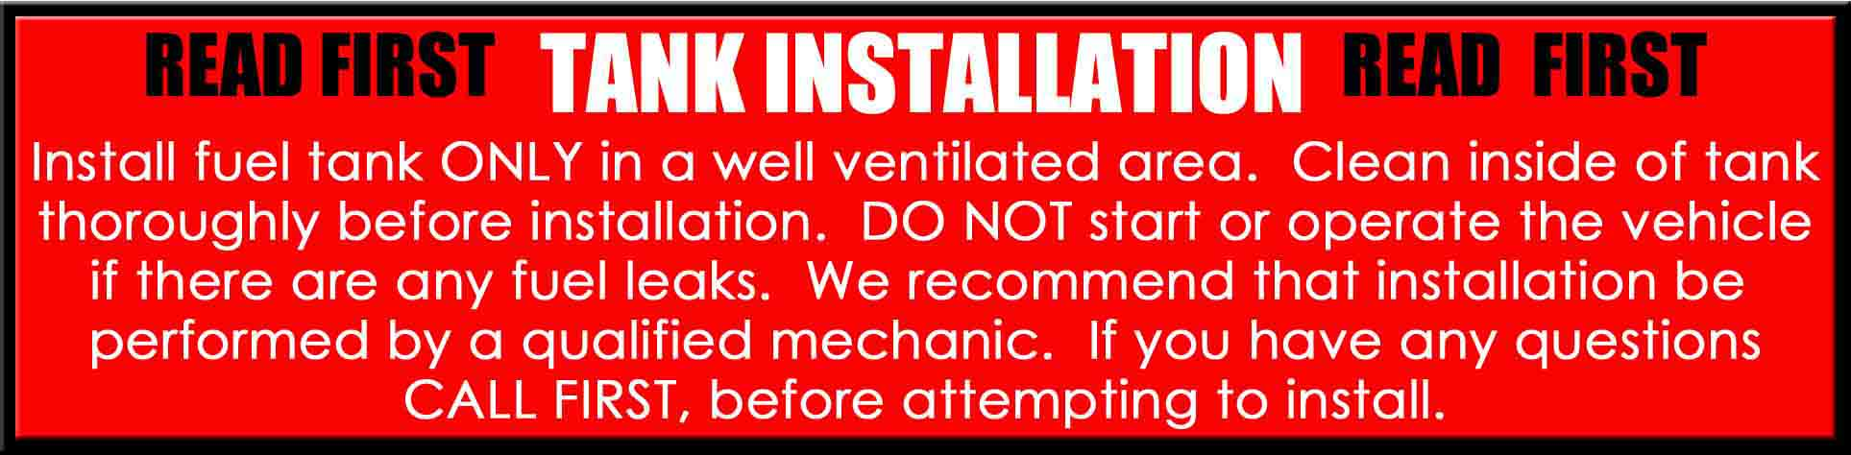

Thank you for purchasing a Clarke fuel tank. The following instructions will help you install this tank on a YZ450F 2010-2011 Fuel Injected dirt bike. There may be some plastic shavings left in the tank from the manufacturing process. You can use compressed air to blow out the tank. You may also want to rinse out the tank using a small amount of fuel before installing it. The instructions on the back side of this page will help you to quickly install your new tank

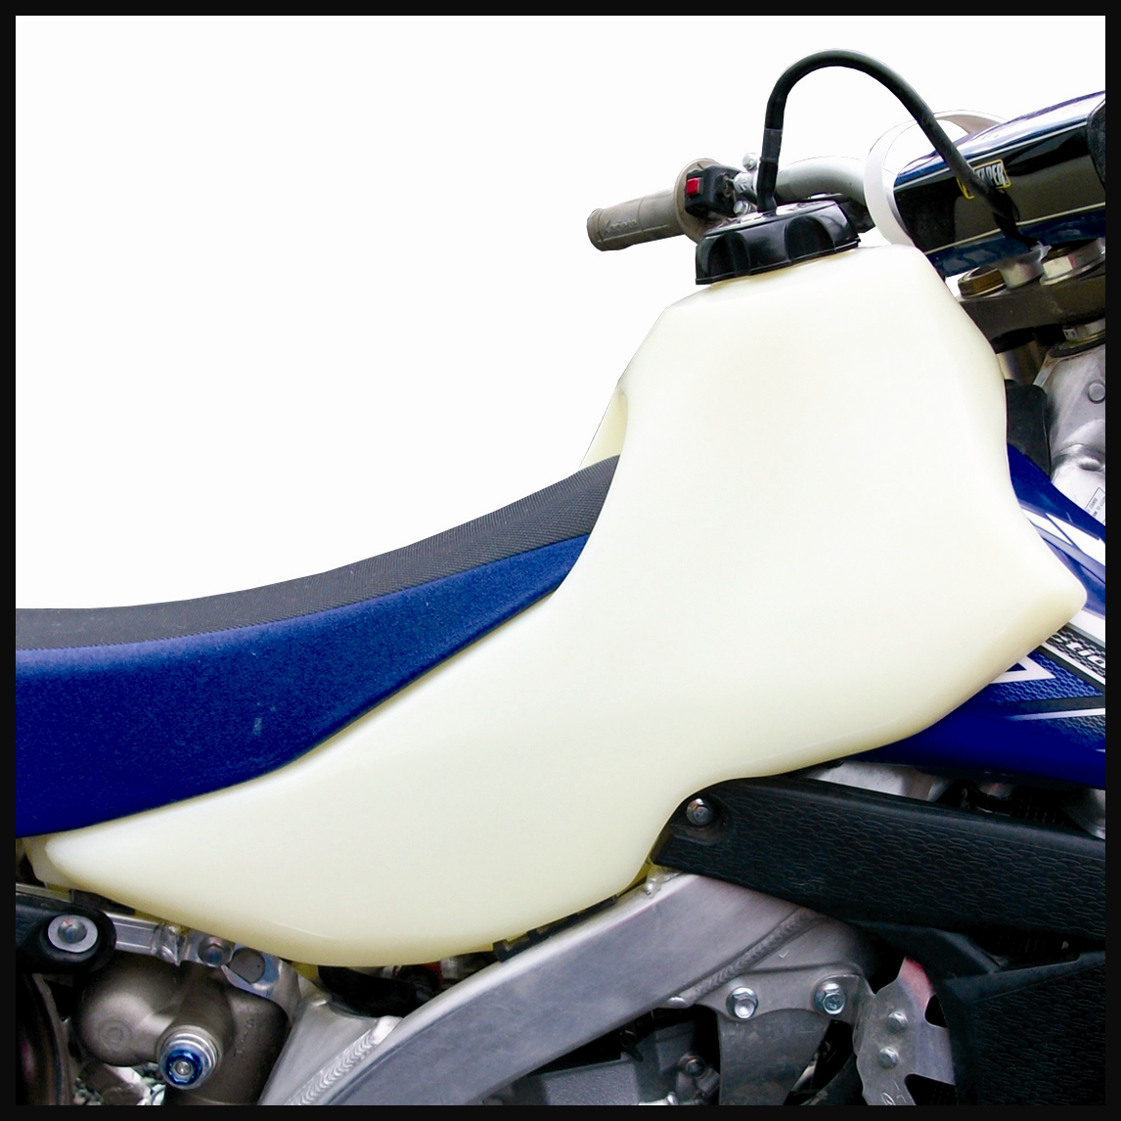

PLEASE SEE THE REVERSE SIDE OF THIS PAGE FOR INSTALLATION INSTRUCTIONS

IMPORTANT: THE MAXIMUM TORQUE SPECS FOR THE FUEL PUMP BOLTS IS 5 FT LBS.
DO NOT EXCEED 5 FT. LBS OF TORQUE WHEN RE-INSTALLING THE FUEL PUMP OR YOU WILL SPIN THE BRASS INSERTS AND VOID THE WARRANTY ON THIS TANK.

1.) Begin by removing your old tank, plastic covers, seat and fuel injection unit. Drain your old tank in a well ventilated area. You may want to refer to your owners/service manual for proper removal and installation of the fuel pump unit.

2.) Remove the fuel pump assembly from your original tank. Now, using the stock bolts, mount the injection unit to the new Clarke tank making sure the seal is not bound and fits tight. A little all purpose oil will aid installation. After you make sure everything is aligned and secure with no o-ring binding, tighten down all the bolts for the unit.

3.) Now put a small amount of fuel into the tank and tip it forward so the gas is located over the fuel pump area. Check for any leakage around the pump seal.

4.) Transfer the rear seat mount stud, the front mounts and the rear factory bracket to the new tank. The tank is now ready for installation.

5.) Slip the tank carefully into the frame and then check to make sure you have no pinched fuel line
or wiring interference.

6.) Align the front and rear mounts over their mounting locations and using the factory bolts, bolt
down the front and rear of the tank.

7.) Now make sure to connect all fuel line etc. then, fill the tank with fuel and check for any leaks.

8.) You can now re-install the seat assembly

9.) Go back and make sure all bolts and screws are secure. You are now ready for riding.
Enjoy your new Clarke tank.

