
Clarke Manufacturing Inc. 13388 S. Molalla Forest Rd. Molalla OR. 97038

Part #11637 (2008-2009) KLX 110
1.6 GALLON FUEL TANK

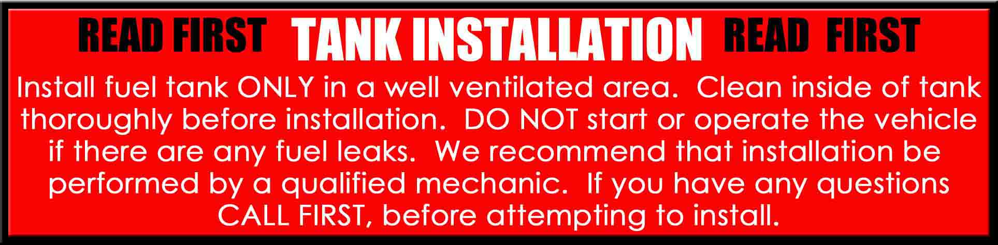

Thank you for purchasing a Clarke fuel tank. The following instructions will help you install this tank on a 2008-2009 KLX 110 There may be some plastic shavings left in the tank from the manufacturing process. You can use compressed air to blow out the tank. You may also want to rinse out the tank using a small amount of fuel before installing it. The instructions on the back side of this page will help you to install your new tank.

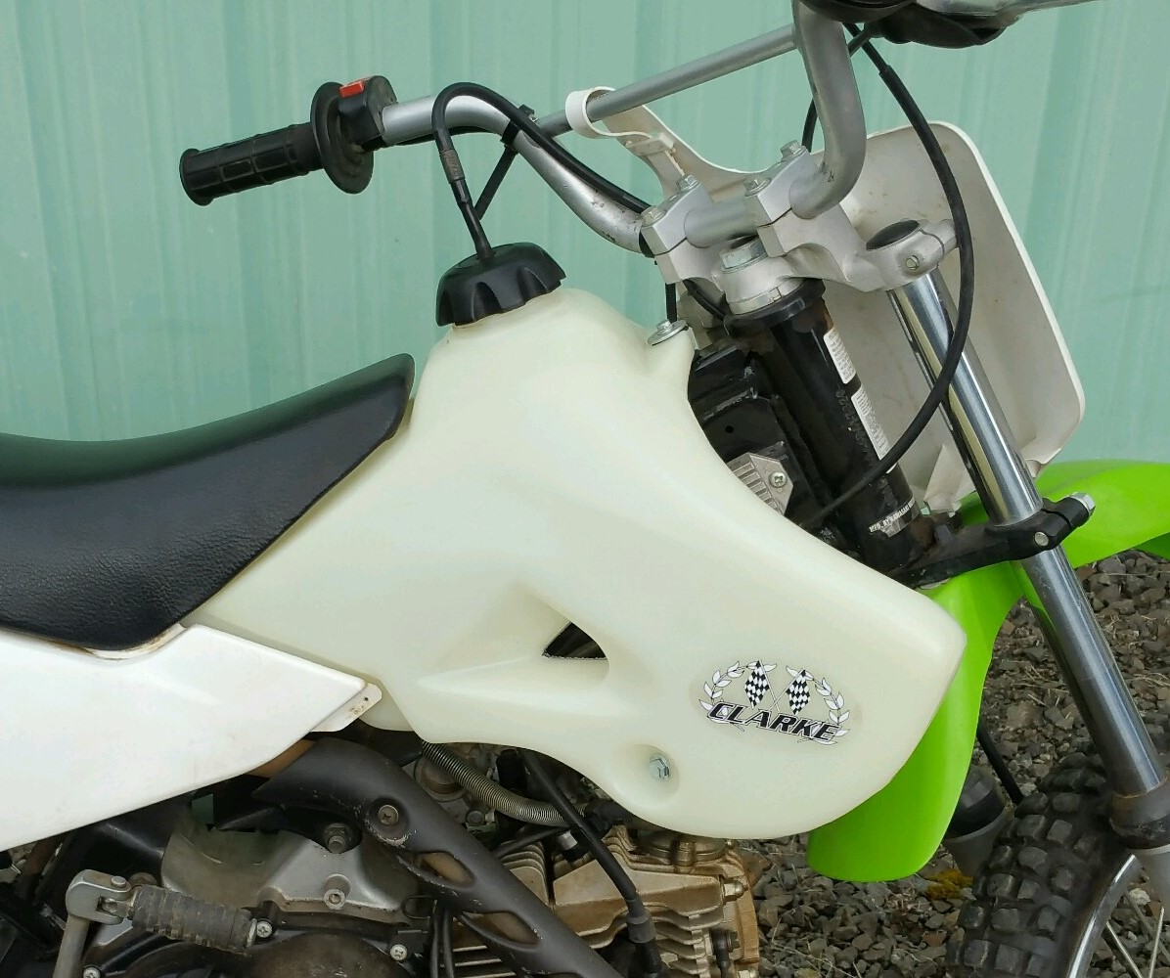

PLEASE SEE THE REVERSE SIDE OF THIS PAGE FOR INSTALLATION INSTRUCTIONS

1.) Begin by draining your old tank in a well ventilated area. Now, remove the seat, shrouds and center mount bushing.

2.) Disconnect the fuel line at the quick connector below the left side of the tank by the throttle body.
You should now be able to remove the original tank from the frame.

3.) On your New Clarke Tank place the OEM Cap, Fuel Valve and 1 of the seat mount screws in the appropriate location. You will no longer need the lower seat mount strap. The Clarke tank will have the necessary hardware for instillation attached to the new tank all other hardware required will be used from your old tank.

4.) The Clarke tank will not require the use of the OEM shrouds. Place the Clarke tank in the correct position and then start the supplied 6mm shroud screws loosely into the factory mount hole. Loosely install the built in shroud section to the mount. Repeat on the opposite side and then tighten the screws down. You will be required to modify the rear plastic piece on both sides. (See Picture) You will be required to drill a ¼ hole in the lower shroud to match up with the bolting hole in the Clarke tank.

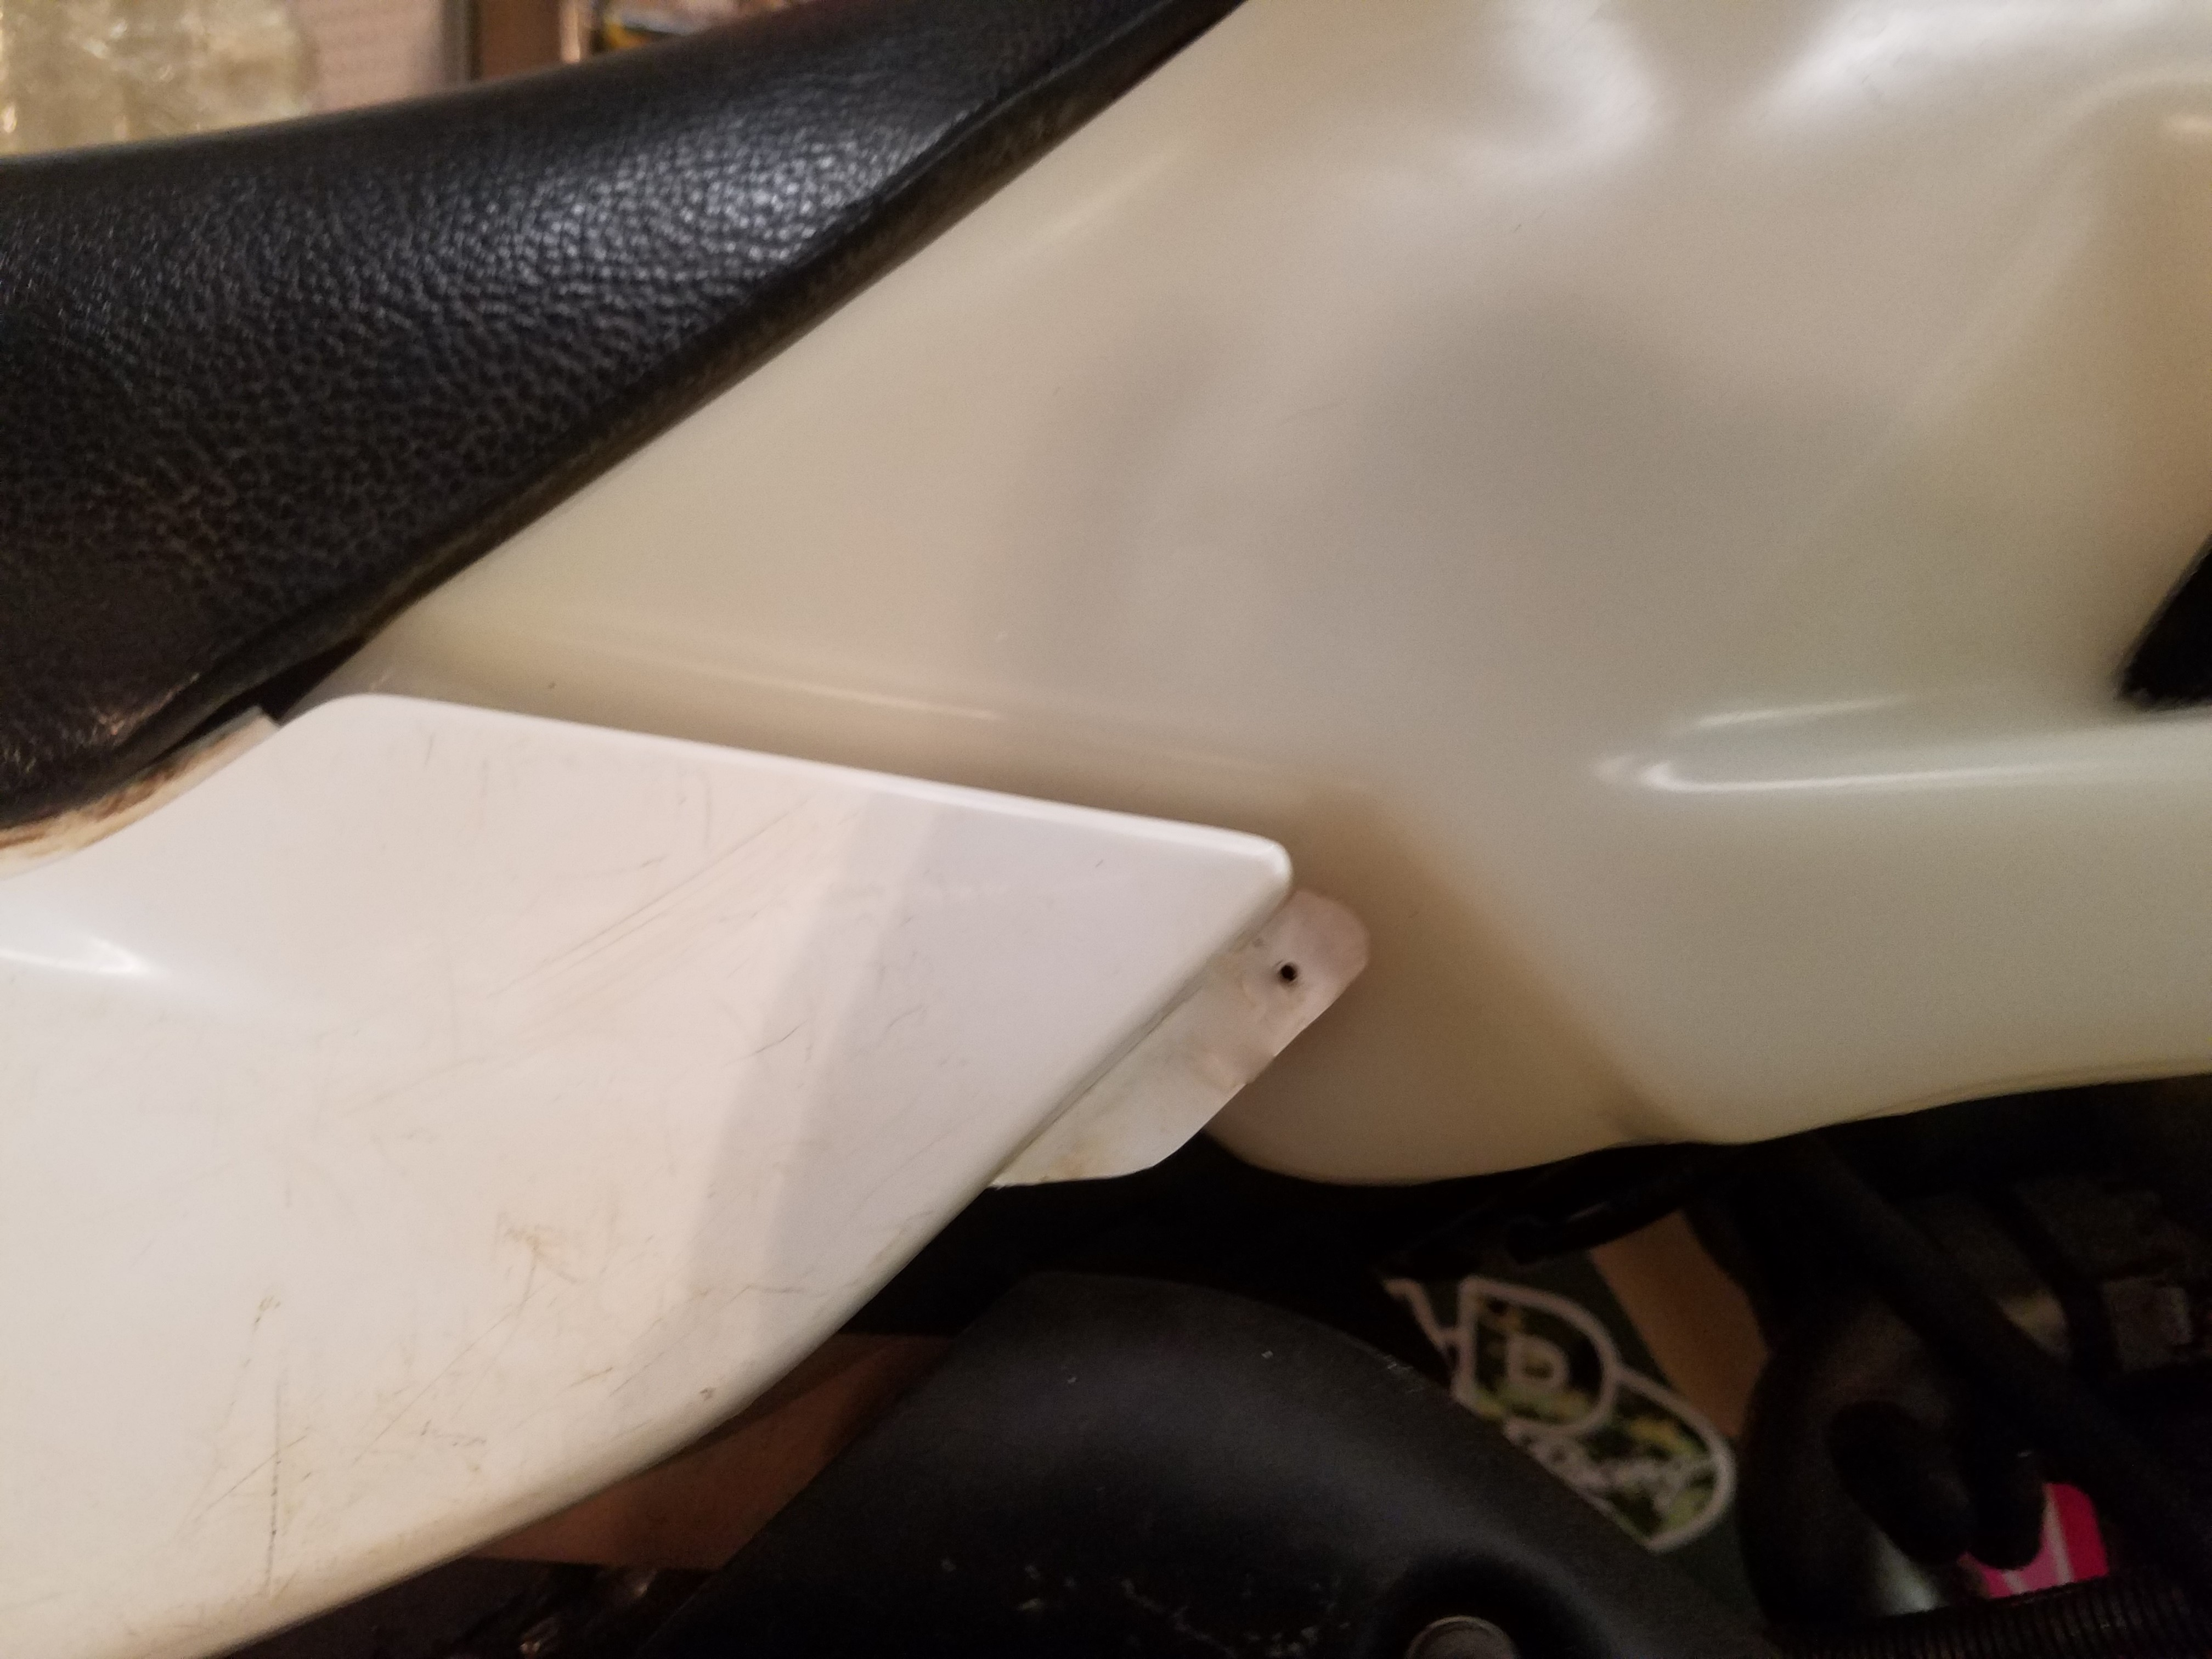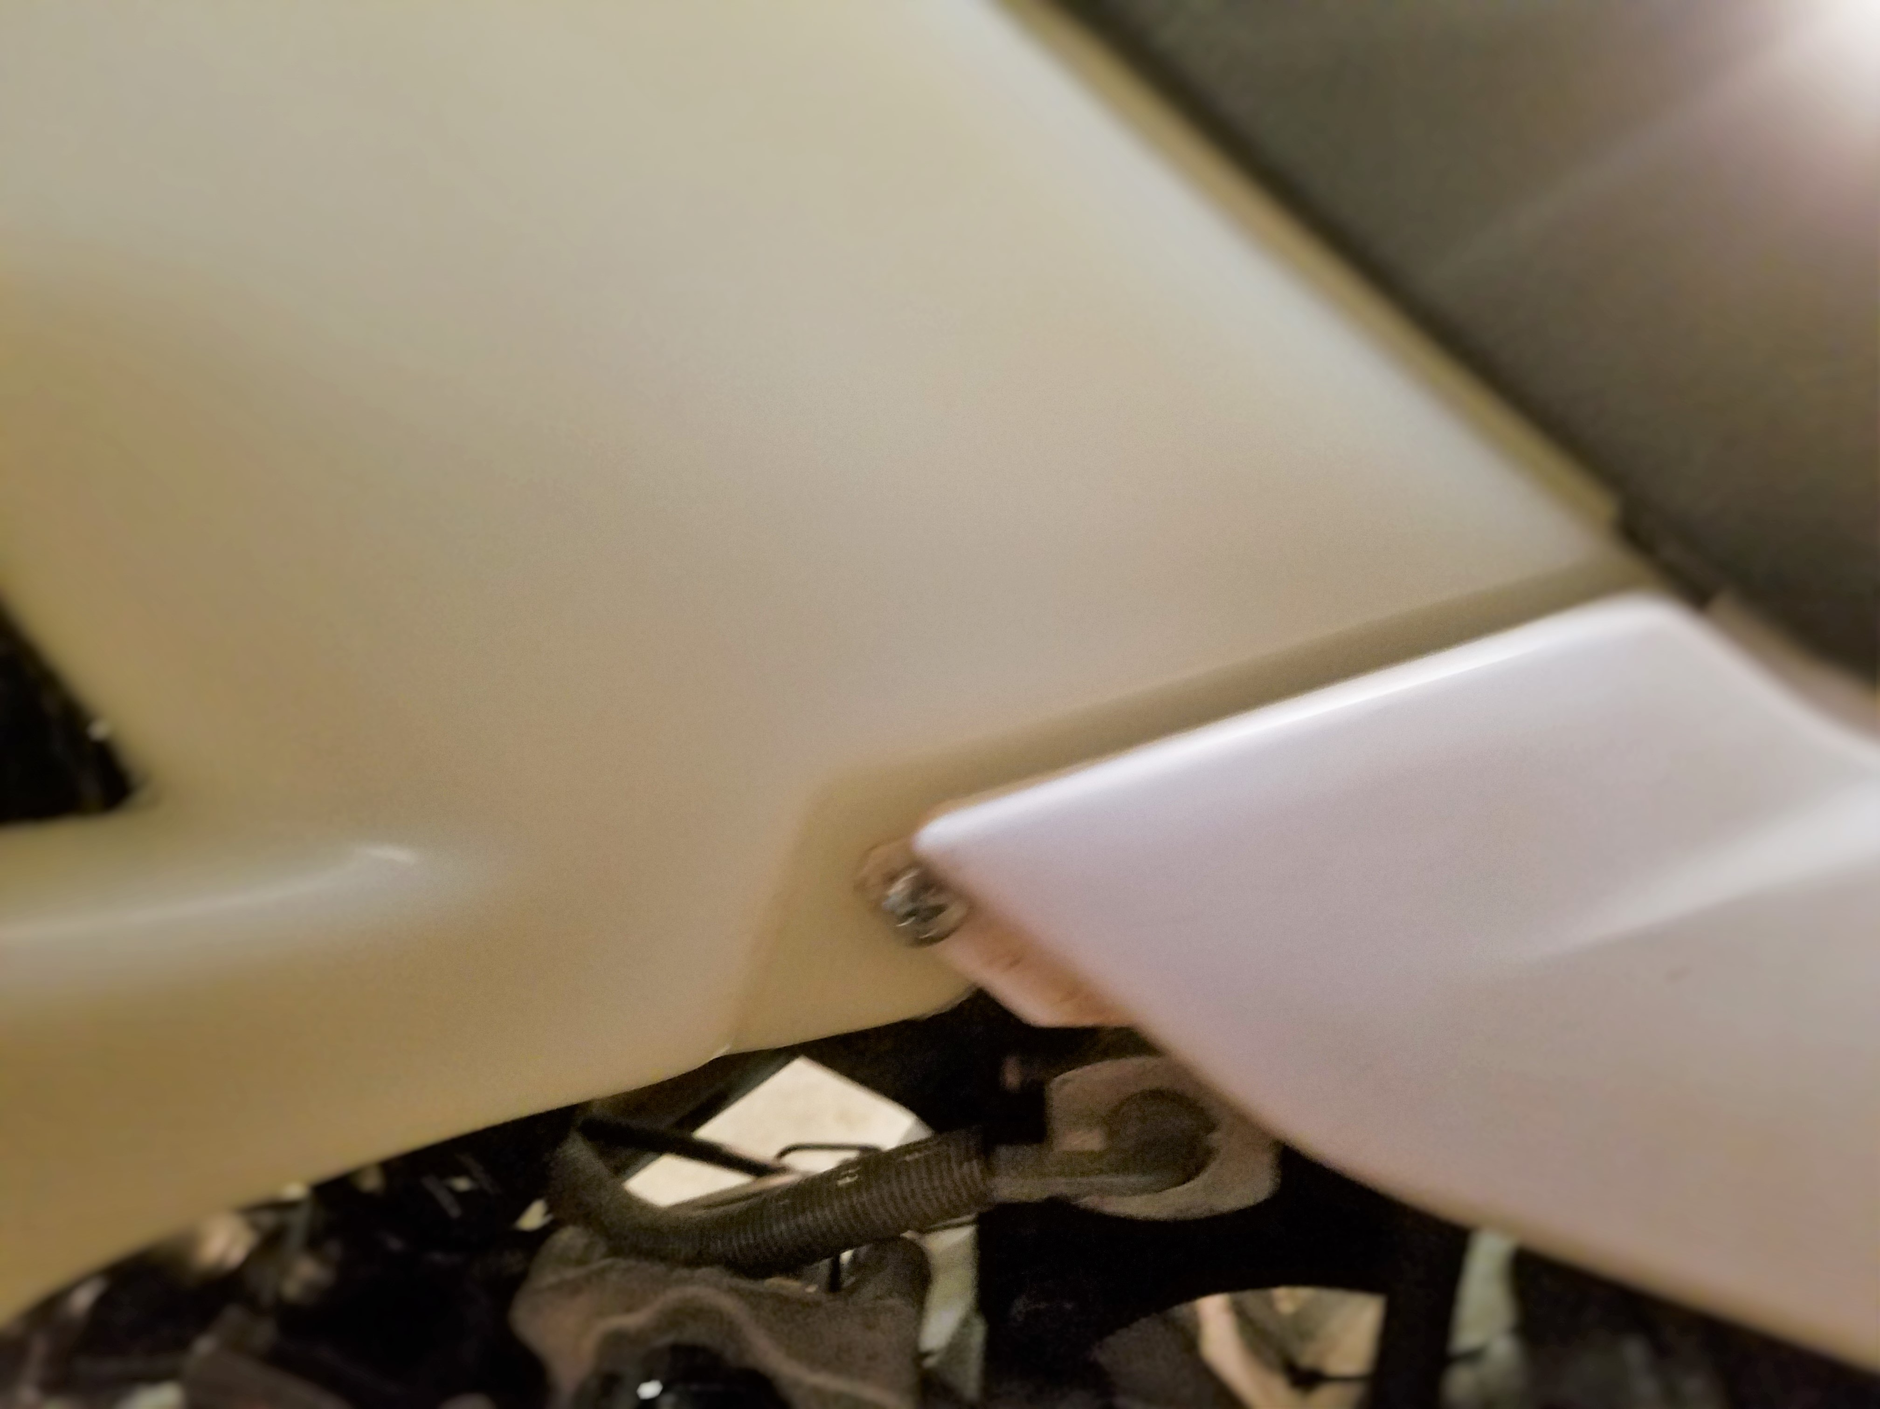
1/4” hole

5.) Now inspect your work and make sure the tank is tight and that it does not pinch or bind cables etc. that could inhibit the controls or function of the bike.

6.) Add some fuel to the tank and check for any leaks.

7.) The new tank includes a new seat mount button, make sure it is tight and then install your seat as usual.

8.) You are now ready for riding. Enjoy your new Clarke tank.

