

Clarke Manufacturing Inc. 13388 S. Molalla Forest Rd. Molalla OR. 97038

Part # 1390 and Part #1391
ATC185 and ATC200M and E. Also ATC200S
3.0 GALLON CAPACITY FUEL TANK

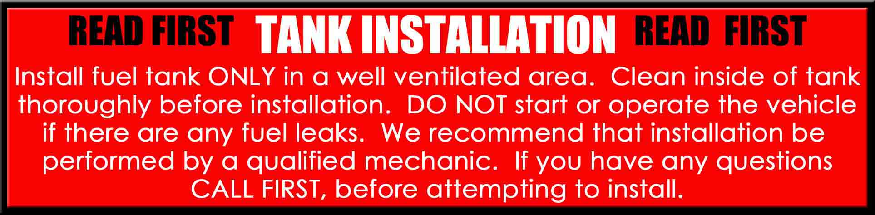

Thank you for purchasing a Clarke fuel tank. These part numbers are intended for use on Honda ATC 185 and ATC200M and E and also for an ATC200S respectively. There may be some plastic shavings left in the tank from the manufacturing process. You can use compressed air to blow out the tank. You may also want to rinse out the tank using a small amount of fuel before installing it. Please note: Before this tank can be installed, the size of the sheet metal piece shown in the illustration must be decreased to provide clearance for the tunnel of the plastic tank. This is best accomplished by squeezing the area with a “C” clamp. Be sure to check the welded area for roughness or sharp edges. Tapping any roughness down with a hammer will cure any problems.
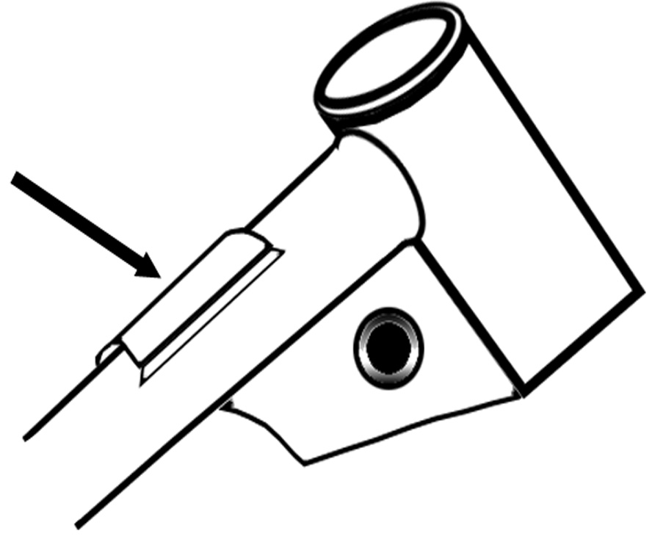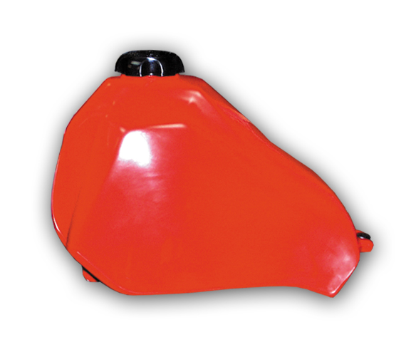
AREA TO CLAMP

PLEASE SEE THE REVERSE SIDE OF THIS PAGE FOR INSTALLATION INSTRUCTIONS

1.) Shut off fuel supply and disconnect fuel line and remove the original tank and petcock. Drain your old tank in a well ventilated area.

2.) Remove the safety bar from inside the tank and set it aside for final installation.

3.) Install your original petcock to the new tank carefully threading it onto the supplied aluminum petcock adapter.

4.) Slide the tank onto the front rubber mounting pucks.

5.) Use your original rear mount bolt to bolt the new tank tightly to the rear mount hole.

6.) Take the safety bar and slide it across and under the front part of the frame and using the supplied
phillips head screws, affix the safety bar to the tank on both sides. The safety bar is simply an extra precaution to keep the tank from lifting off of the frame.

7.) Now hook up the fuel line, turn the petcock to the OFF position and fill the tank with gas.

8.) Check for leaks.

9.) Re-install the rear fender and seat assembly.

10.) You are now ready for riding. Enjoy your new Clarke tank.

