

Clarke Manufacturing Inc. 13388 S. Molalla Forest Rd. Molalla OR. 97038

Part # 1326 TRX250X and TRX300EX
2.7 GALLON FUEL TANK



Thank you for purchasing a Clarke fuel tank. This tank is intended for use on the TRX250X and TRX300EX. There may be some plastic shavings left in the tank from the manufacturing process. You can use compressed air to blow out the tank. You may also want to rinse out the tank using a small amount of fuel before installing it. Please note that this tank may not fit with after market steering stems.

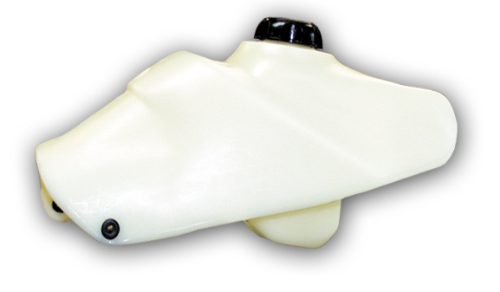

PLEASE SEE THE REVERSE SIDE OF THIS PAGE FOR INSTALLATION INSTRUCTIONS

1.) Remove the rear seat and fender assembly. Also remove the front fender assembly.

2.) Shut off fuel supply and disconnect fuel lines and remove the original tank and petcock.
Drain your old tank in a well ventilated area.

3.) Make sure the petcock adapter is tight on the new tank and the o-ring is lined up under it properly.
Take your cock and insert it into the new tank. Carefully thread the outer nut onto the new aluminum adapter while aligning the plastic flow indicator with the side of the tank and tighten the nut.

4.) Remove the rubber piece from the original front mount hole.

5.) Slide the tank onto the frame and hook up the gas line. Then spread the tank slightly to go over the rear mounting tabs.

6.) Adjust the tank and tighten the 2 rear bolts.

7.) The front mount will slip into the front mount hole about ¼”. Over a period of time the entire tank will grow in length.

8.) Now hook up the fuel lines, turn the petcock to the OFF position and fill the tank with gas.

9.) Check for leaks.

10.) Re-install the front fender assembly and rear fender and seat assembly taking care to make sure
all bolts are re-installed and tight.

11.) You are now ready for riding. Enjoy your new Clarke tank.

