
Clarke Manufacturing Inc. 13388 S. Molalla Forest Rd. Molalla OR. 97038

Part #11496 KTM 4 STROKES AND 2 STROKES (2008-2009)
3.1 GALLON FUEL TANK



Thank you for purchasing a Clarke fuel tank. The following instructions will help you install this tank on a 2008-2009 KTM 4 stroke OR 2 Stroke motorcycle. There may be some plastic shavings left in the tank from the manufacturing process. You can use compressed air to blow out the tank. You may also want to rinse out the tank using a small amount of fuel before installing it. The instructions on the back side of this page will help you to install your new tank.

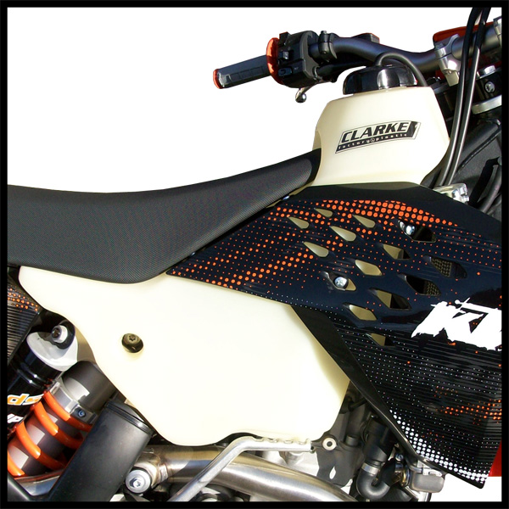

PLEASE SEE THE REVERSE SIDE OF THIS PAGE FOR INSTALLATION INSTRUCTIONS
1.) Begin by removing your old tank, shrouds and petcock. Drain your old tank in a well ventilated area.

2.) Install your original petcock in the new tank using the supplied 6mm screws.

3.) Loosely fit the tank to the frame but do not yet push it down. Stand on the right side of the bike and reach over the bike with your left hand to the lower part of the tank near the petcock and grab a hold of the
tank. Pushing down and forward, the tank will go down onto the mounts and into it’s final position.

4.) Re-install the original factory center mount spacer and bolt and affix the tank to the
center mount frame post.

5.) The new Clarke tank is supplied with larger than stock 6mm pan head screws. You may want to enlarge the holes on your factory shrouds to ¼” to accommodate them and make the shrouds easier to align to your new tank.

6.) Locate the shrouds to their correct position and then start the supplied 6mm shroud screws loosely to the tank. Using the factory radiator mount bolt, loosely install the lower shroud section to the radiator
mount. Repeat on the opposite side and then tighten the screws down.

7.) Now hook up the fuel line, turn the petcock “off” and fill the tank with gas.

8.) Check for leaks.

9.) Re-install the seat and fasten the seat mount bolt securely.

10.) You are now ready for riding. Enjoy your new Clarke tank.

