
Clarke Manufacturing Inc. 13388 S. Molalla Forest Rd. Molalla OR. 97038

Part # 1479 2000-2007 DRZ400 “E” and KLX400 “R”
3.6 GALLON FUEL TANK

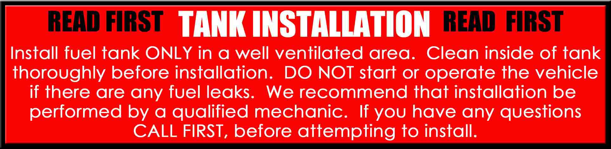

Thank you for purchasing a Clarke fuel tank. The following instructions will help you install this tank on a 2000-2007 DRZ400E or KLX400R motorcycle. There may be some plastic shavings left in the tank from the manufacturing process. You can use compressed air to blow out the tank. You may also want to rinse out the tank using a small amount of fuel before installing it. The instructions on the back side of this page will help you to install your new tank properly.
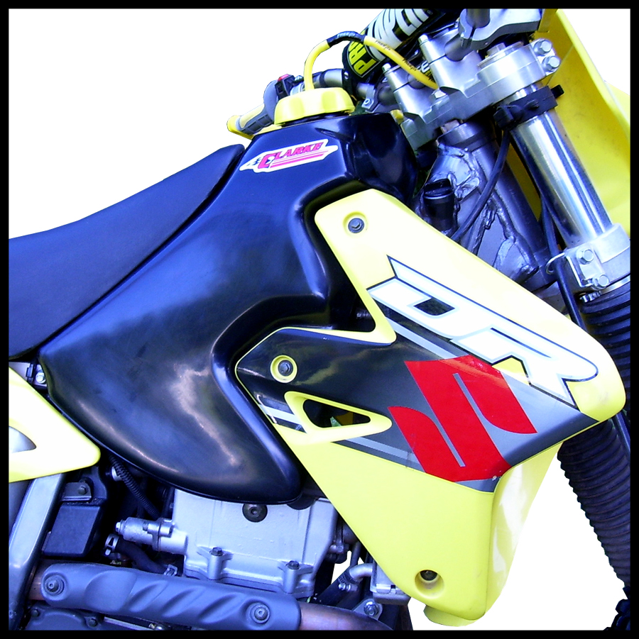

PLEASE SEE THE REVERSE SIDE OF THIS PAGE FOR INSTALLATION INSTRUCTIONS

1.) Begin by removing your old tank, shrouds and petcock. Drain your old tank in a well ventilated area.

2.) Install your original petcock in the new tank using the new petcock gasket in combination with the original “oval o-ring” that is currently on your OE petcock.

3.) Transfer the original set of front mounts from your original tank to the new tank using the hardware that is supplied by the original manufacturer.

4.) Now place the tank over the frame and push it into position. Align the bushing area with the mounting holes on the frame. Get one bolt partially started, then move to the other side and start the other bolt in. Once both mounting bolts are started go back and tighten them down.

5.) Transfer the rear seat mount bracket and the rear strap mount screw from your original tank
to the new tank.

6.) Install all shroud bolts loosely on the tank section using the original shroud bolts and loosely install
the radiator mount bolts.

7.) Now tighten the shroud and radiator mount bolts and attach the rubber strap to the rear screw.

8.) Turn the petcock to the OFF position and fill the tank with fuel.

9.) Check for leaks.

10.) Re-install the seat and fasten the seat mount bolts securely.

11.) You are now ready for riding. Enjoy your new Clarke tank.

