
Clarke Manufacturing Inc. 13388 S. Molalla Forest Rd. Molalla OR. 97038

Part # 1483 KAWASAKI KDX200 (97-07) and KDX220 (00-06)
3.6 GALLON FUEL TANK

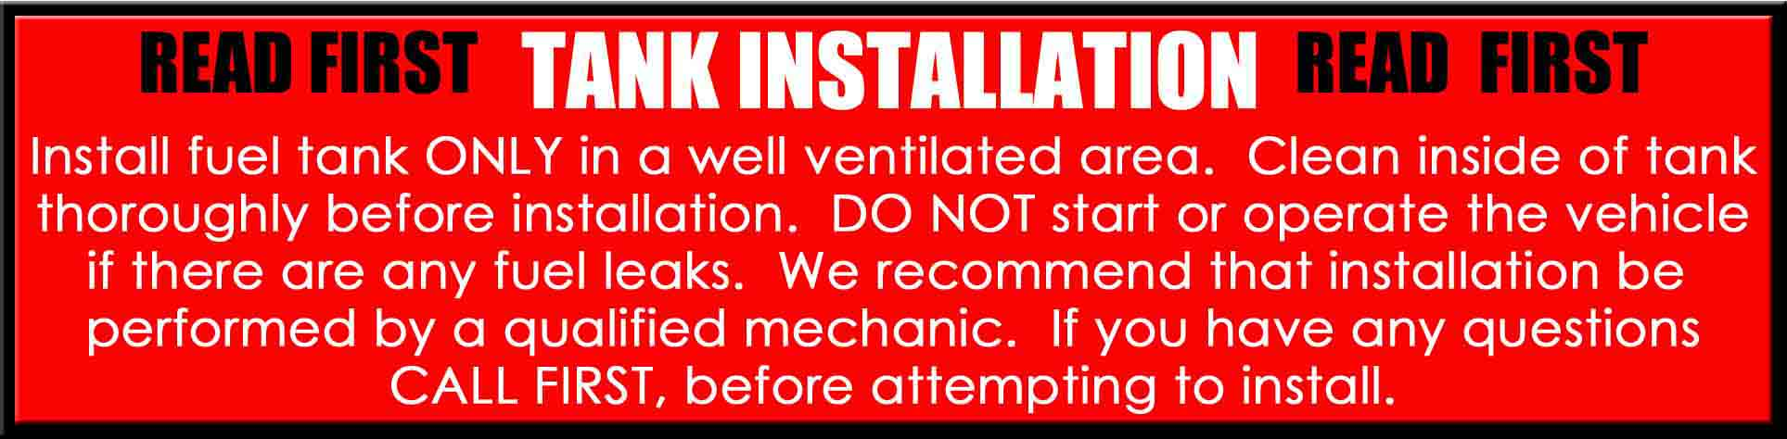

Thank you for purchasing a Clarke fuel tank designed to fit the KDX200 and KDX220. There may be some plastic shavings left in the tank from the manufacturing process. You can use compressed air to blow out the tank. You may also want to rinse out the tank using a small amount of fuel before installing it. The instructions on the back side of this page will help you to install your new tank properly. Upon purchase and installation the consumer assumes all liability and is solely responsible for compliance with all local and federal laws.

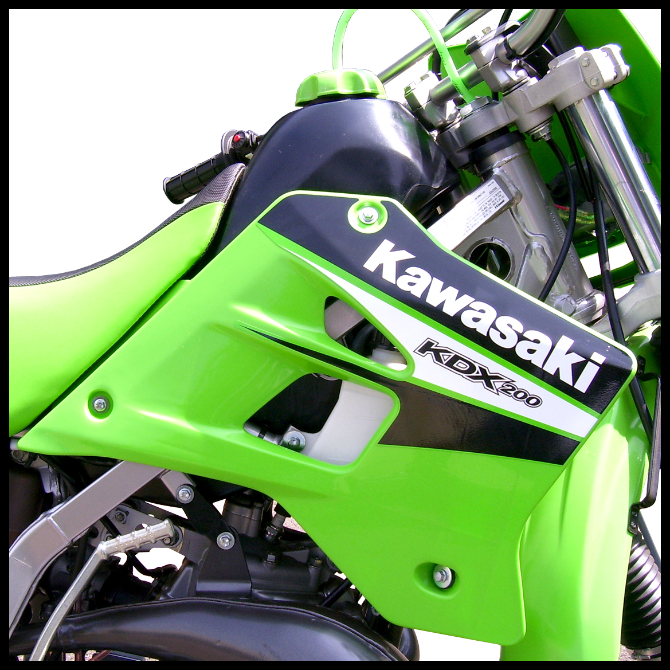

PLEASE SEE THE REVERSE SIDE OF THIS PAGE FOR INSTALLATION INSTRUCTIONS

1.) Begin by removing the seat and shrouds from the bike.

2.) Drain any remaining fuel from the OEM tank in a well ventilated area and then make sure that
the petcock is turned to “OFF”

3.) Remove the bolts from the main tank mounts on the sides and at the rear of the original tank.

4.) You can now completely remove the original tank from the bike. There will no doubt be a small amount of fuel left in the tank so be careful when removing the tank to avoid additional fuel spillage.

5.) Turn your original tank over and remove the original petcock and transfer it to the new Clarke tank.

6.) Now place the Clarke tank into the frame and wiggle it down into position between the side mount bushings. It will be a nice tight fit.

7.) Now install the side mount bolts by starting one side in a few threads and then doing the same with the other side. Once you have both side mount bolts started and you are happy with where everything is, go ahead and tighten down the mount bolts.

8.) Using needle nose pliers, work carefully and install the fuel lines onto the petcock and route the hoses to the carburetor making sure they are pushed all the way on and that the hose clamps are back to their original positions.

9.) Now fill the tank and check for leaks. Clarke tanks are pressure tested with air before they are shipped, but this is a necessary precaution. Make sure the petcock is still in the “OFF” position.

10.) Now transfer the rear seat mount stud to the new Clarke Tank and transfer the rear tank strap and screw as well.

11.) You can now re-install your radiator shrouds. Start all bolts loosely and then tighten them down.

12.) Now install the seat. It can be difficult to see because the seat is in the way of what you are trying to view. Hold the front of the seat tight against the tank and hold the tail of the seat up in the air by bending the seat down and forward at the front. Slide the seat forward and onto the groove making sure to also get the plastic seat base “hook” to go under the area where it needs to be. Now go ahead and align the rear
seat mount bolts and tighten them down.

13.) You are now ready for riding. Enjoy your new Clarke tank and the additional range you will gain from the extra capacity.

